Programming Process

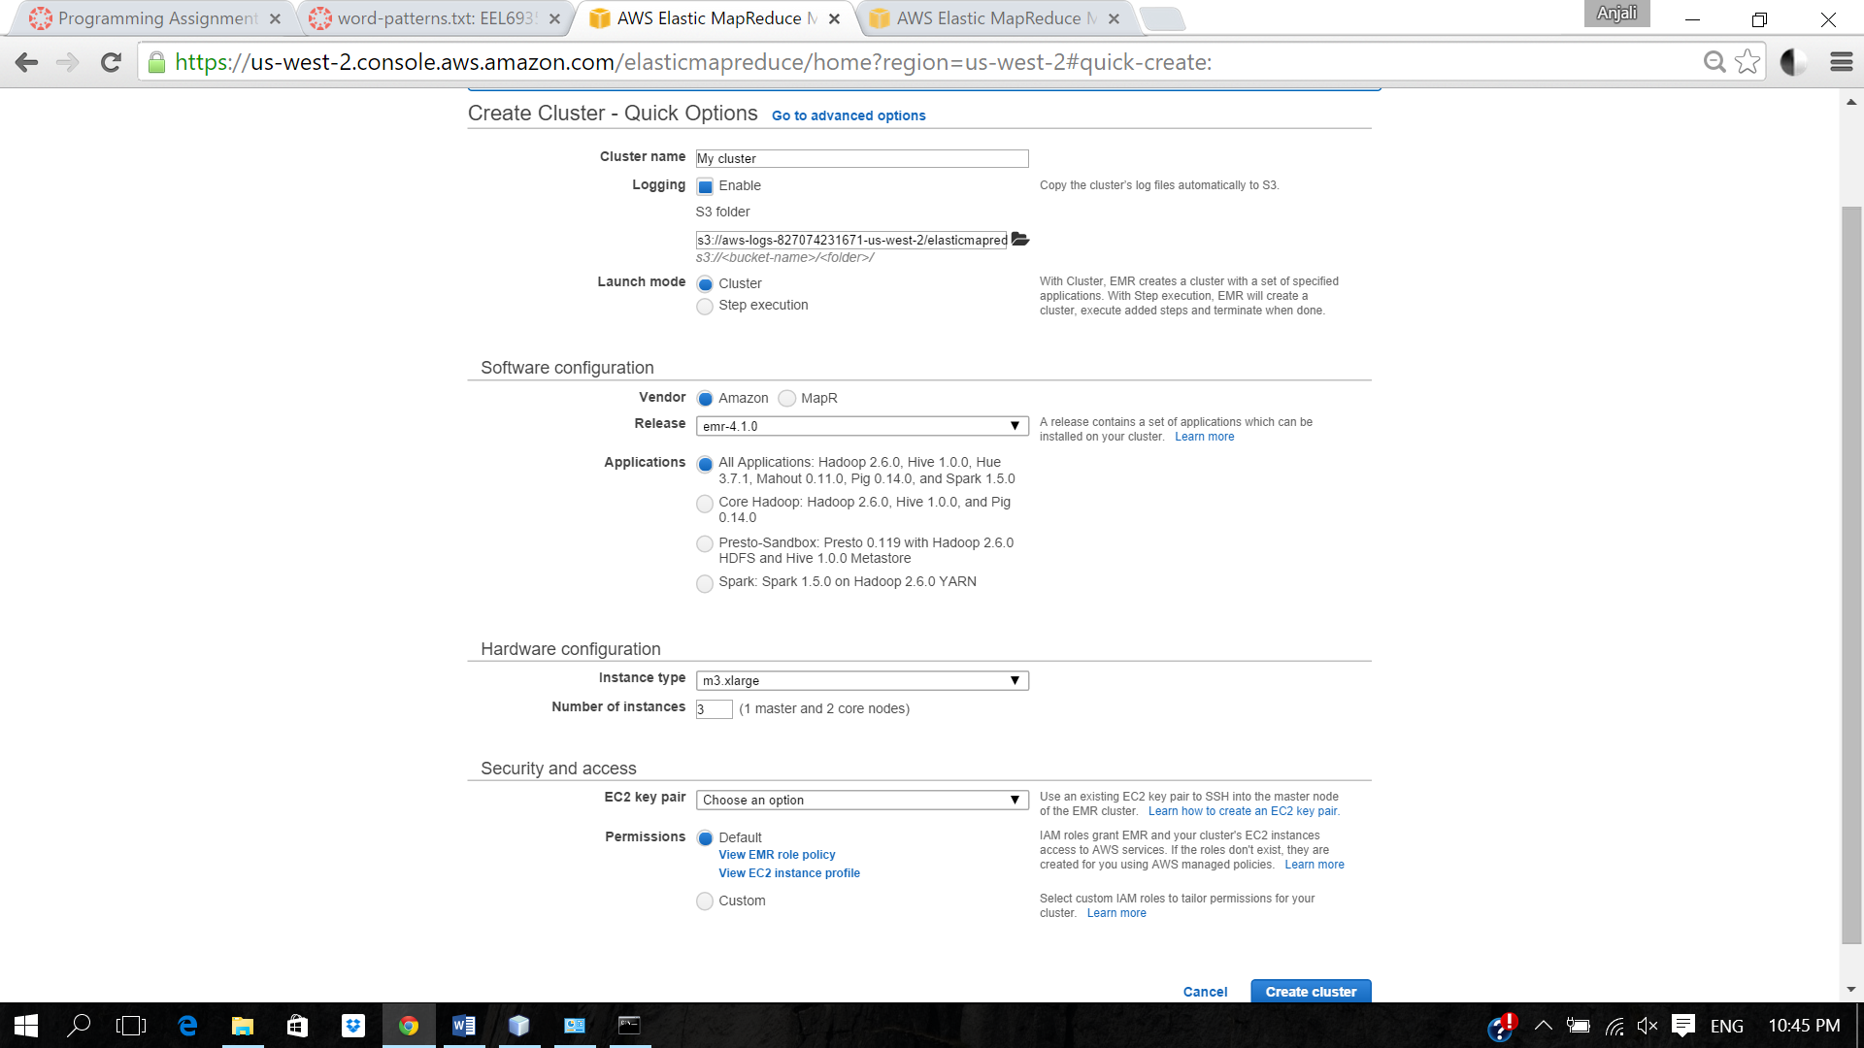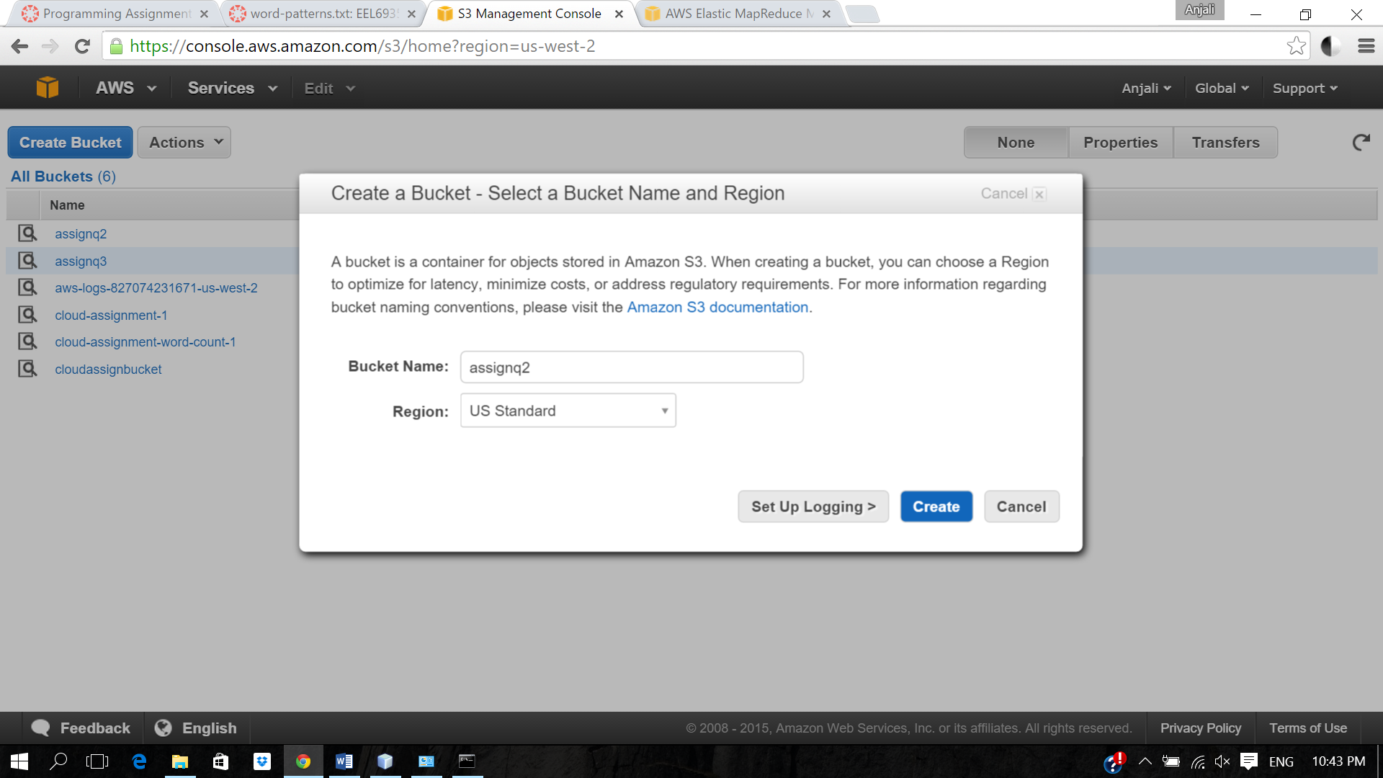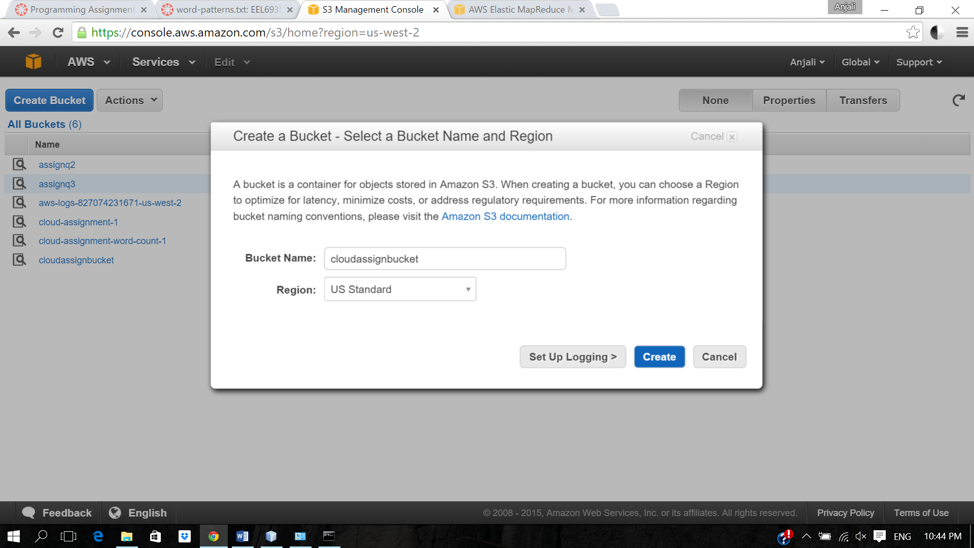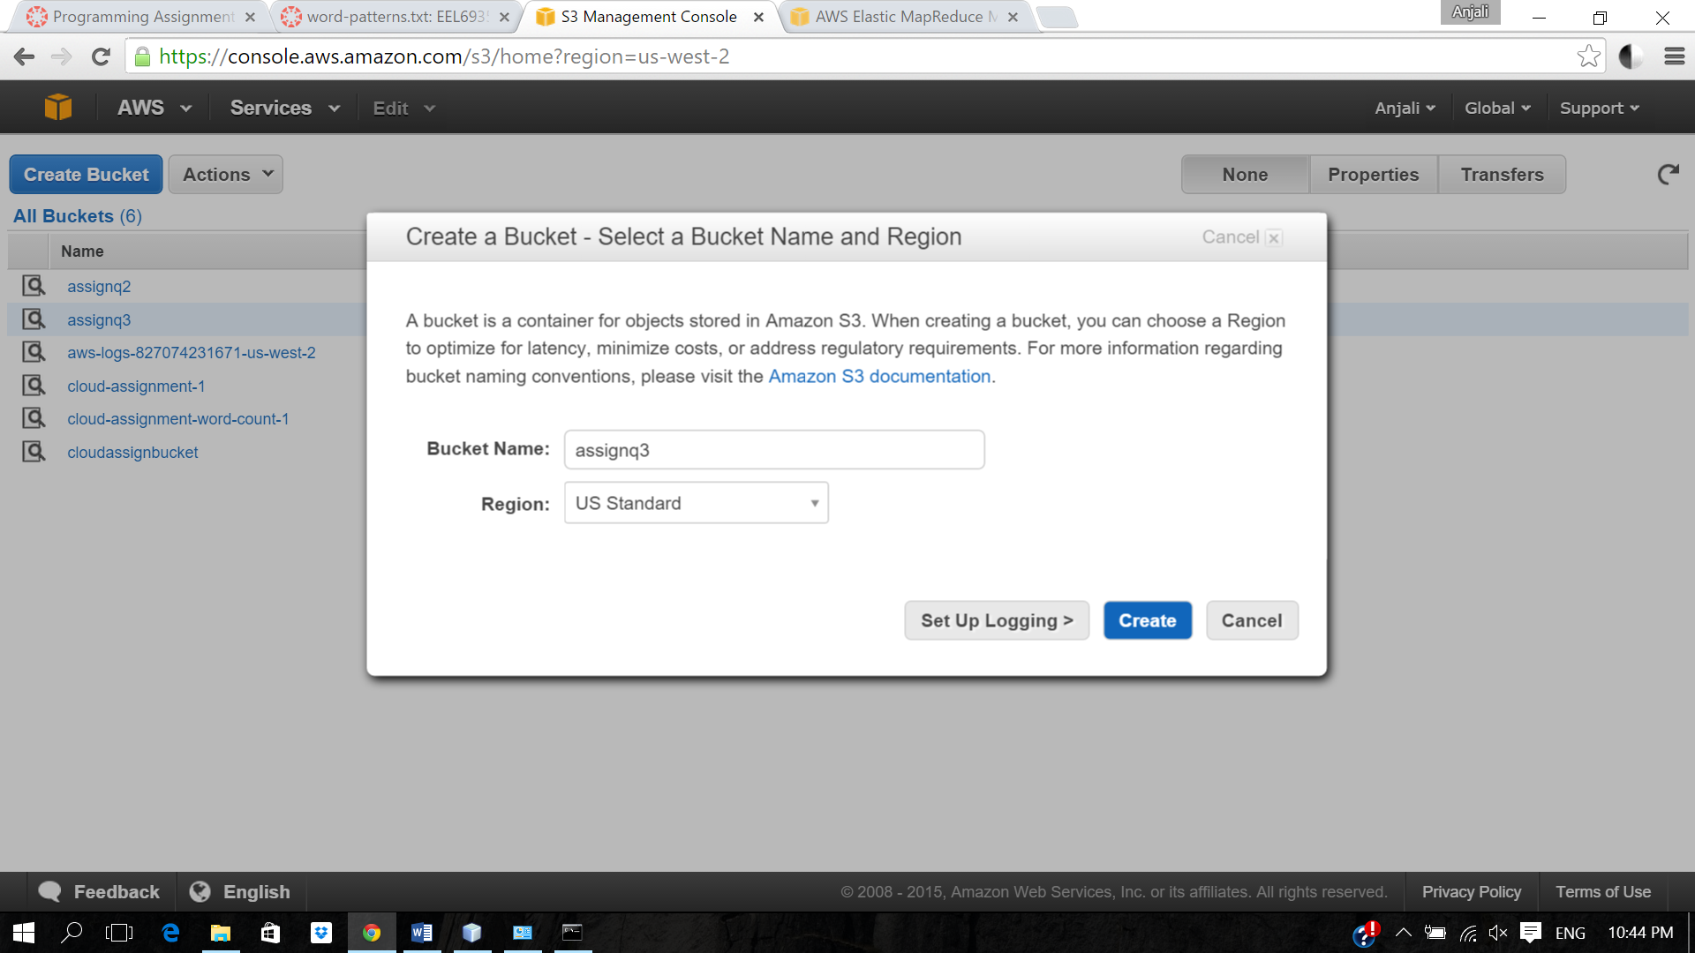

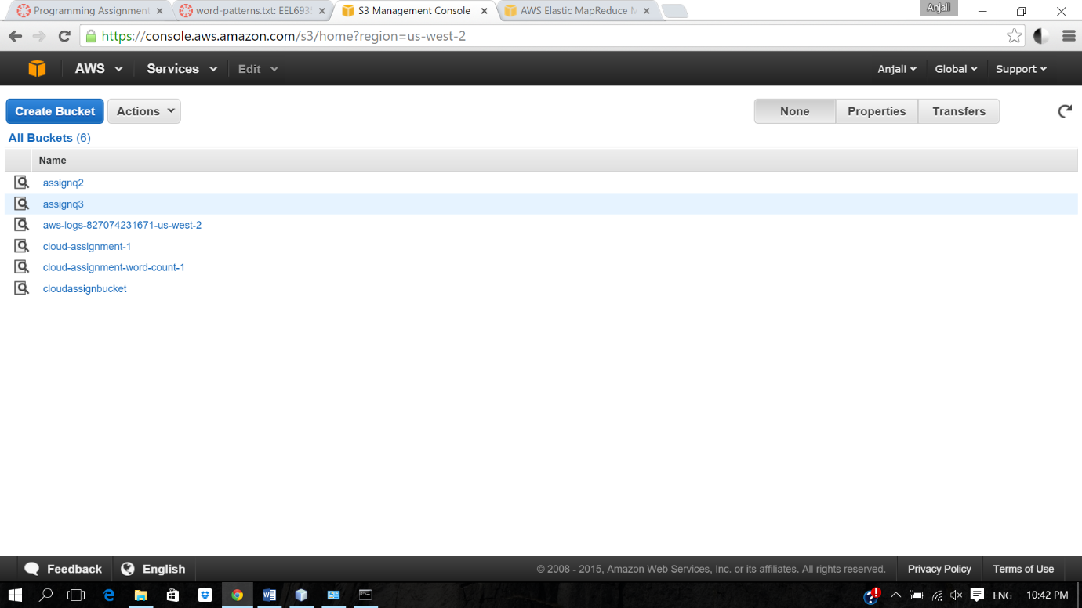

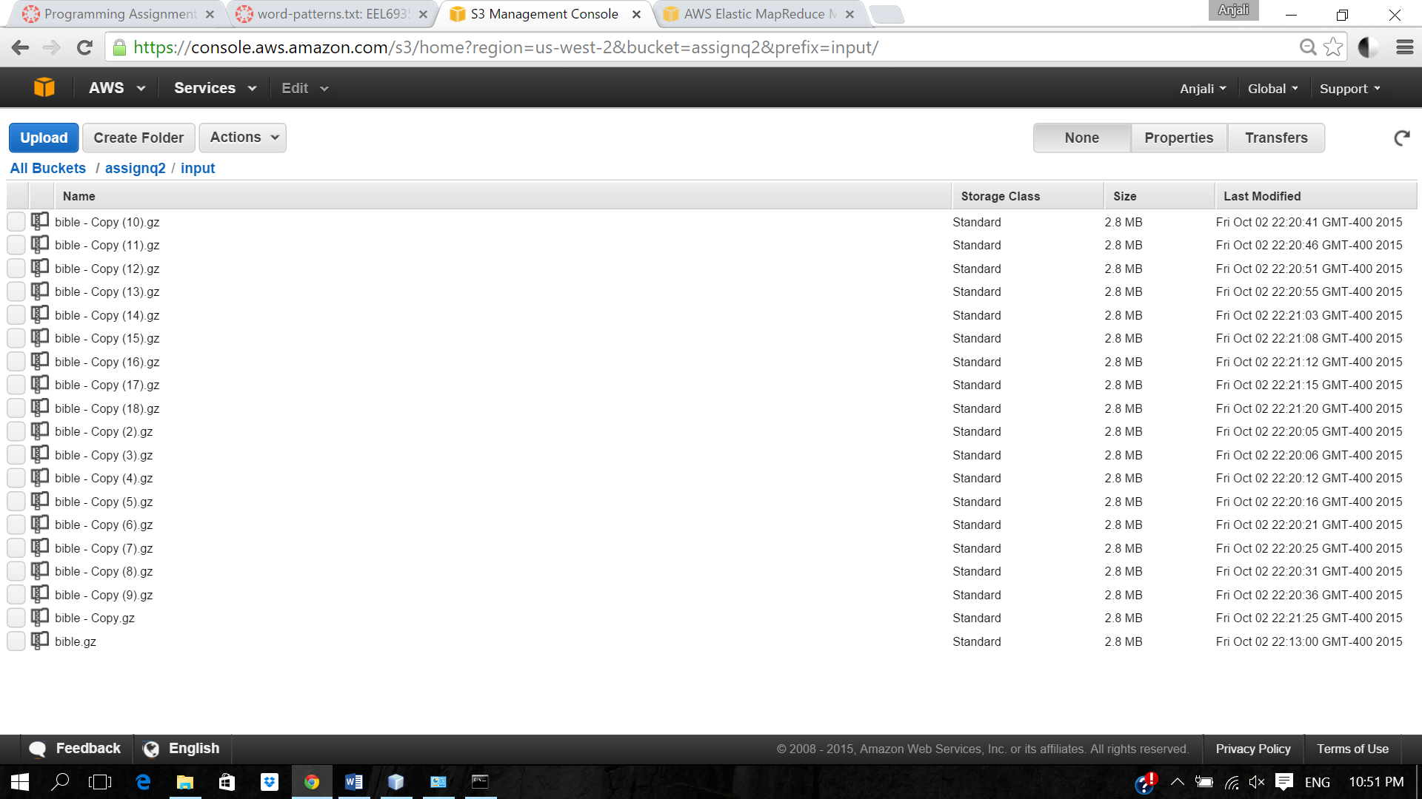

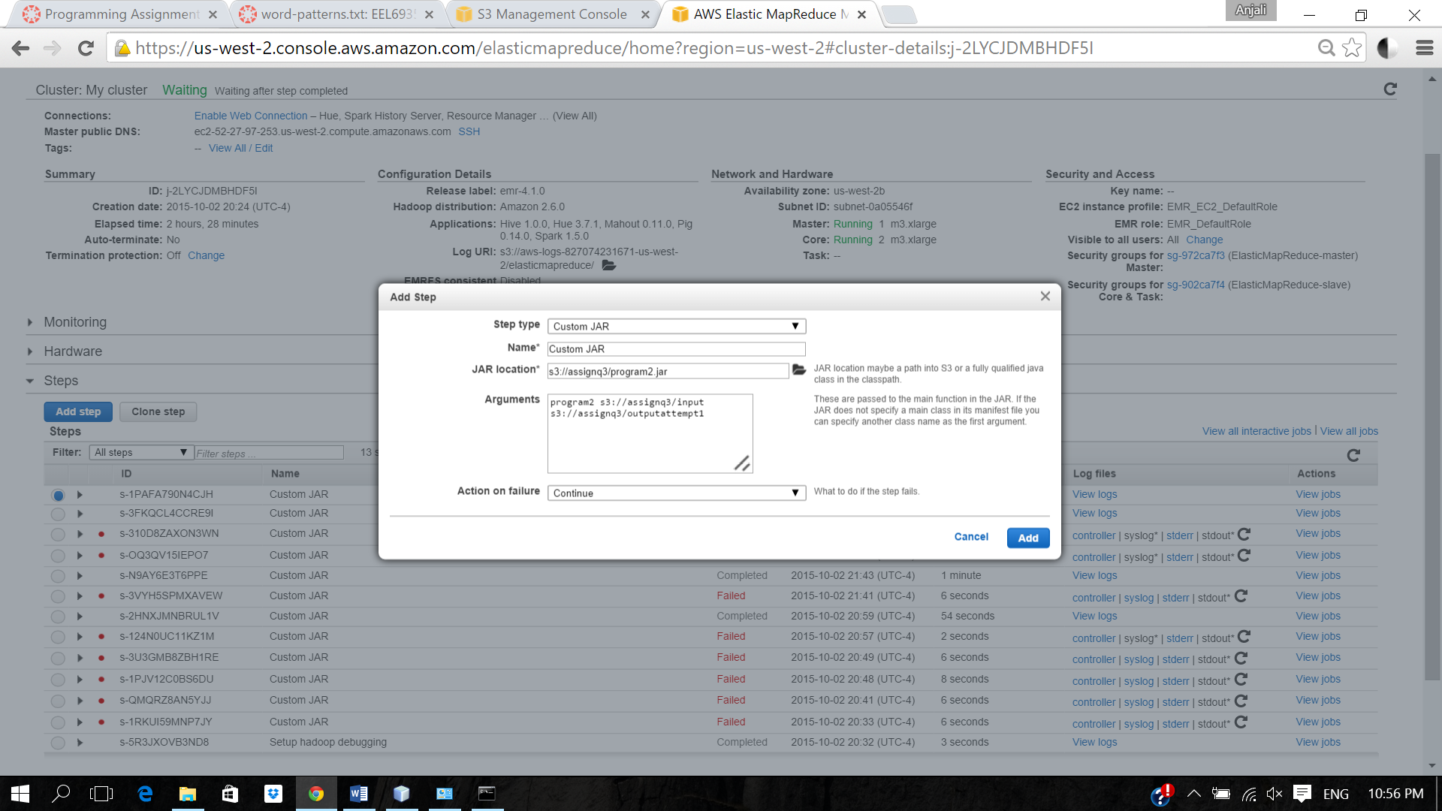

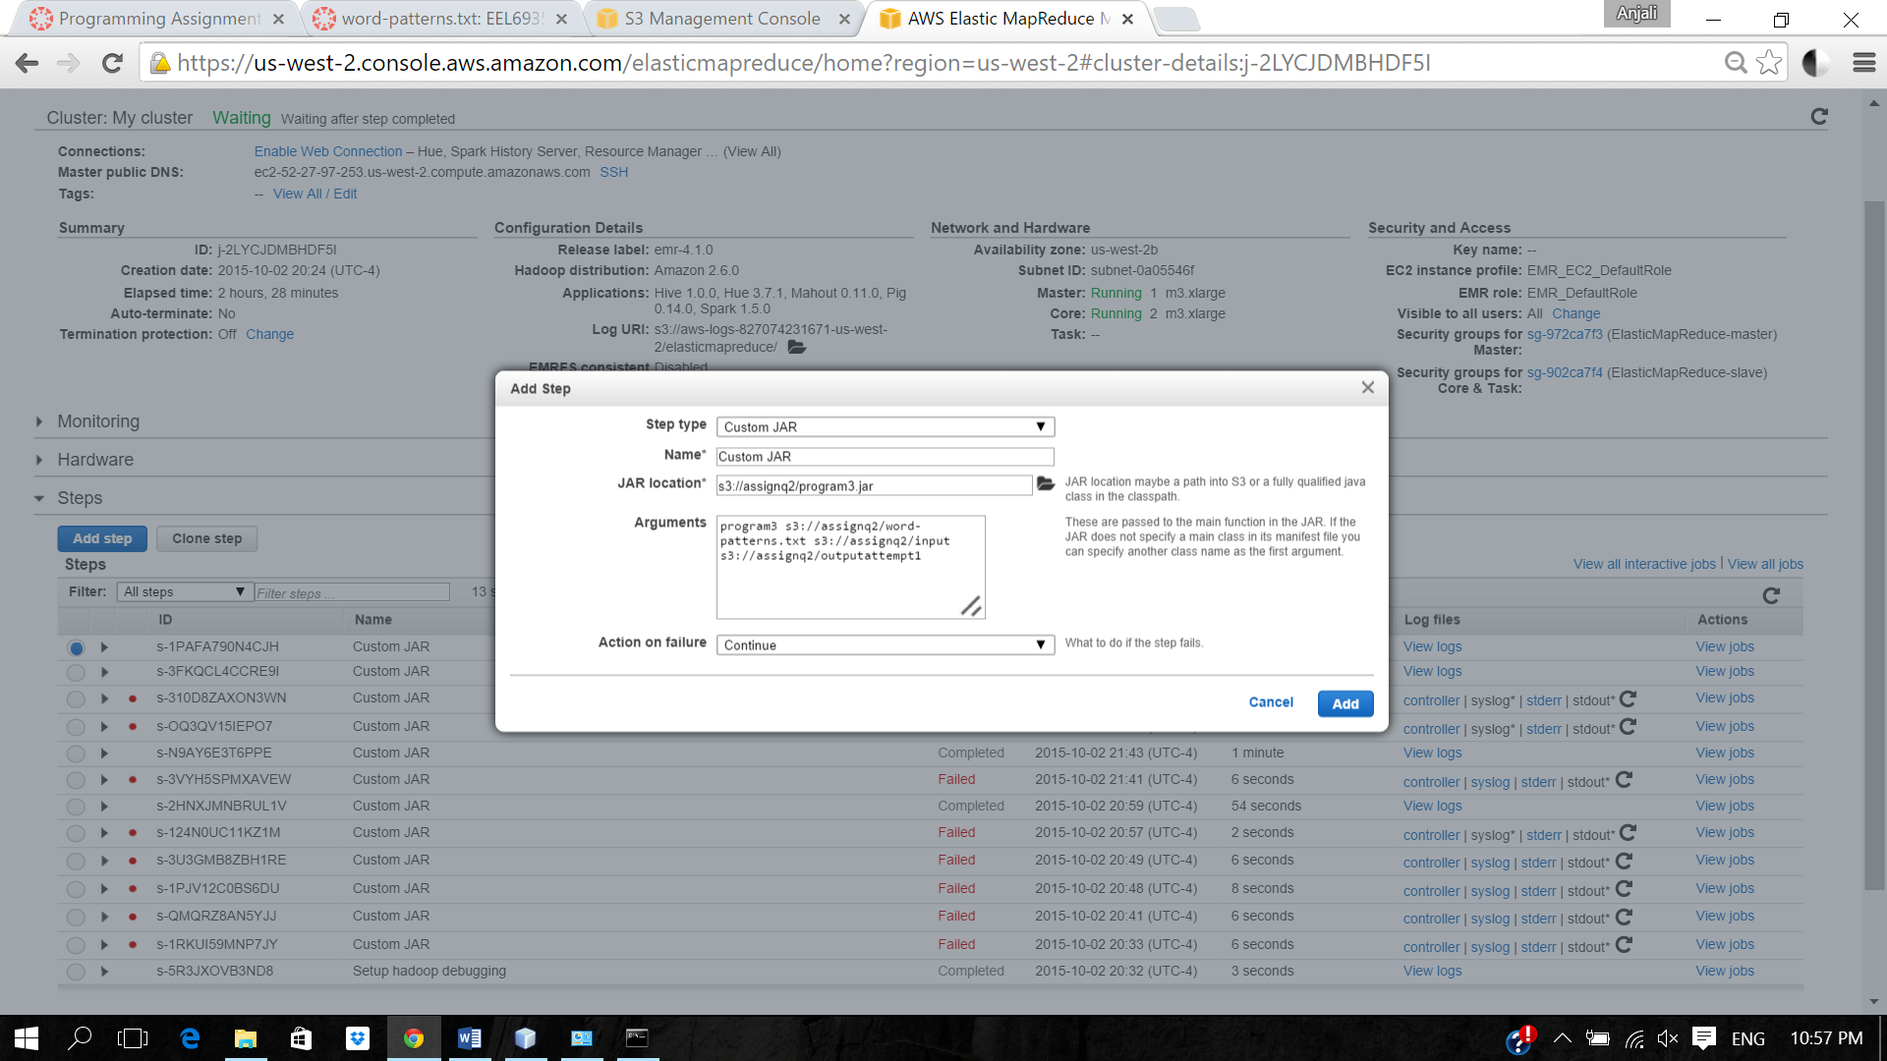

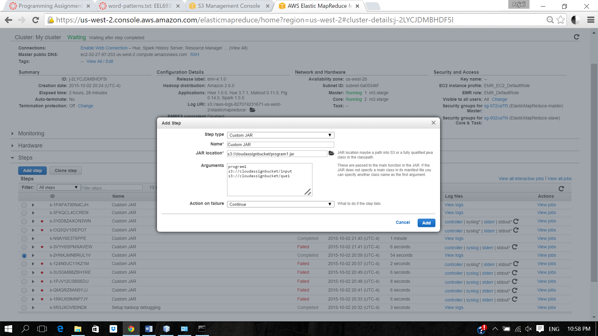

Final

Outputs

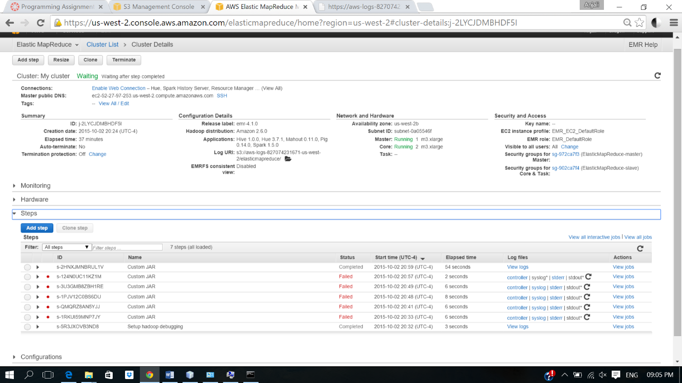

Question 1

**OUTPUT LINKS**

* <https://s3-us-west-2.amazonaws.com/cloudassignbucket/que1a2/_SUCCESS>
* <https://s3-us-west-2.amazonaws.com/cloudassignbucket/que1a2/part-r-00000>
* <https://s3-us-west-2.amazonaws.com/cloudassignbucket/que1a2/part-r-00001>
* <https://s3-us-west-2.amazonaws.com/cloudassignbucket/que1a2/part-r-00002>
* <https://s3-us-west-2.amazonaws.com/cloudassignbucket/que1a2/part-r-00003>
* <https://s3-us-west-2.amazonaws.com/cloudassignbucket/que1a2/part-r-00004>
* <https://s3-us-west-2.amazonaws.com/cloudassignbucket/que1a2/part-r-00005>
* <https://s3-us-west-2.amazonaws.com/cloudassignbucket/que1a2/part-r-00006>

Question 3

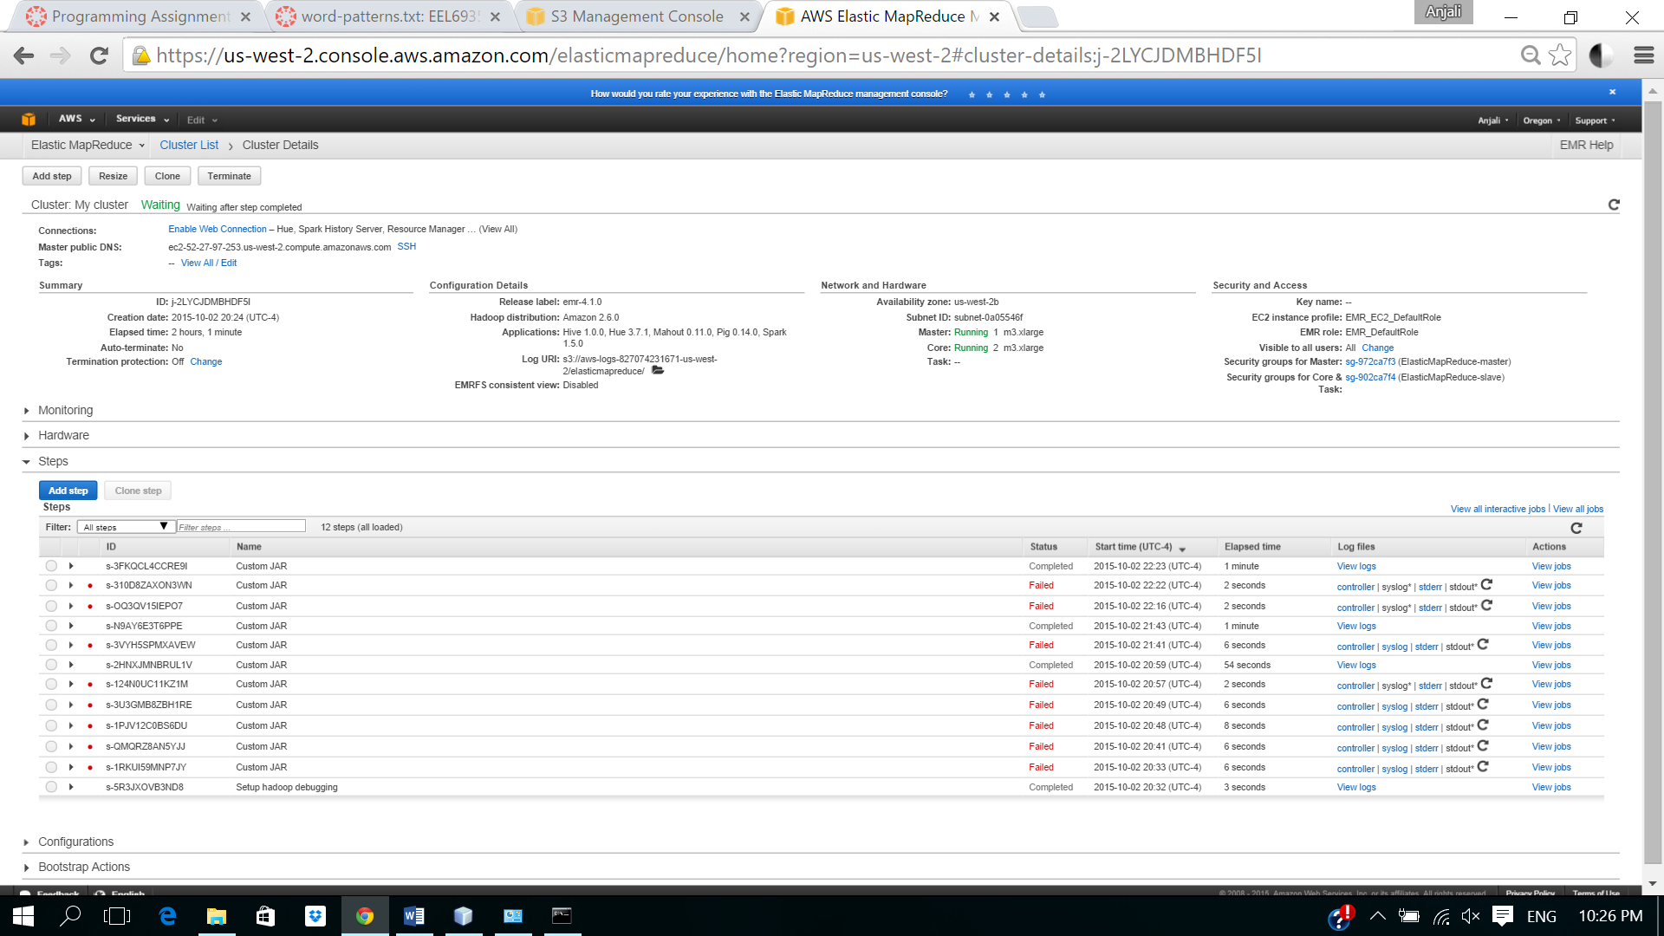

**OUTPUT LINKS**

* <https://s3-us-west-2.amazonaws.com/assignq2/outputattempt1/_SUCCESS>
* <https://s3-us-west-2.amazonaws.com/assignq2/outputattempt1/part-r-00000>
* <https://s3-us-west-2.amazonaws.com/assignq2/outputattempt1/part-r-00001>
* <https://s3-us-west-2.amazonaws.com/assignq2/outputattempt1/part-r-00002>
* <https://s3-us-west-2.amazonaws.com/assignq2/outputattempt1/part-r-00003>
* <https://s3-us-west-2.amazonaws.com/assignq2/outputattempt1/part-r-00004>
* <https://s3-us-west-2.amazonaws.com/assignq2/outputattempt1/part-r-00005>
* <https://s3-us-west-2.amazonaws.com/assignq2/outputattempt1/part-r-00006>

Question 2

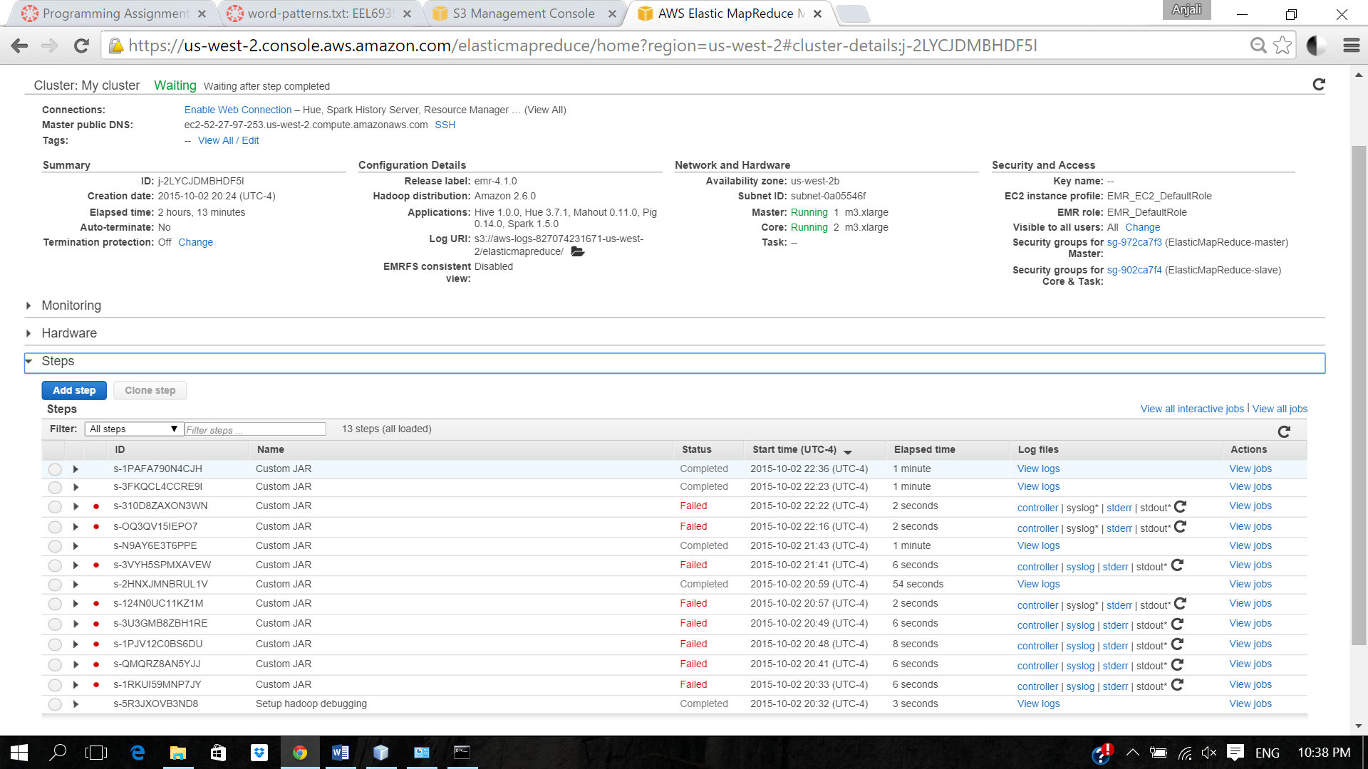

**OUTPUT LINKS**

* <https://s3-us-west-2.amazonaws.com/assignq3/outputattempt1/_SUCCESS>
* <https://s3-us-west-2.amazonaws.com/assignq3/outputattempt1/part-r-00000>
* <https://s3-us-west-2.amazonaws.com/assignq3/outputattempt1/part-r-00001>
* <https://s3-us-west-2.amazonaws.com/assignq3/outputattempt1/part-r-00002>
* <https://s3-us-west-2.amazonaws.com/assignq3/outputattempt1/part-r-00003>
* <https://s3-us-west-2.amazonaws.com/assignq3/outputattempt1/part-r-00004>
* <https://s3-us-west-2.amazonaws.com/assignq3/outputattempt1/part-r-00005>
* <https://s3-us-west-2.amazonaws.com/assignq3/outputattempt1/part-r-00006>

Question 2

